

**Project**

**Submitted By:** Ashna Wasif (2791)  
**Class**: BSCS 7B (Morning)

**Subject**: French (Foreign Language)

**Submitted To:** Mr. Sarfraz Abbass

**Date:** 1st June, 2025

Topic: French Monuments

1. **Louvre Museum (Musée du Louvre):**

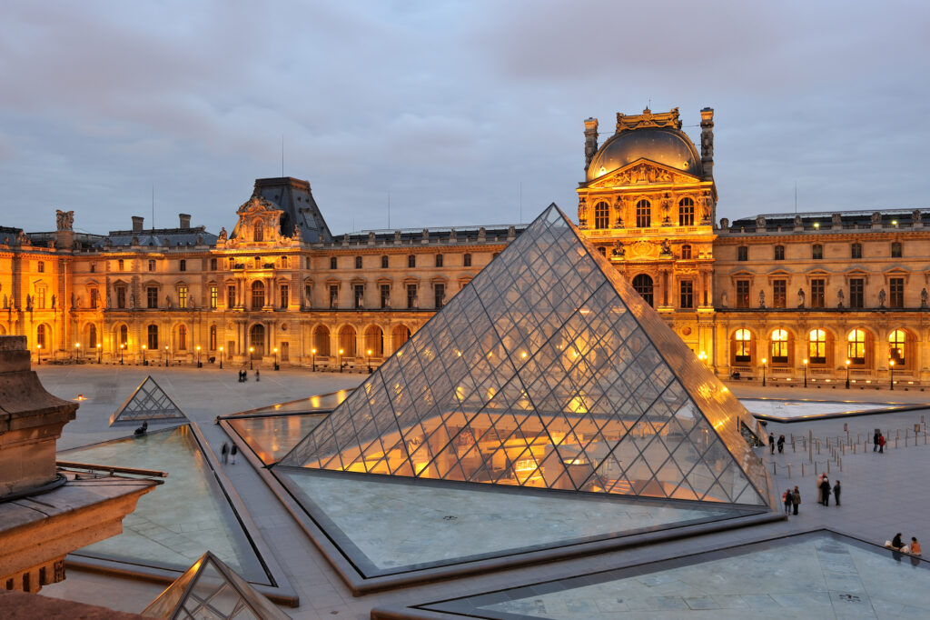The Louvre is one of the most famous museums in the world. It is located in Paris and used to be a royal palace. Today, it holds many famous artworks, including the Mona Lisa. The building is very large and beautiful, with a big glass pyramid at the entrance. People from all over the world come to visit it. Inside, there are paintings, statues, and ancient items from many countries.

1. **Panthéon:**

The Panthéon is a big and old building in Paris. It was built to be a church but now it honors famous people from French history. Inside, you can see the tombs of writers, scientists, and leaders like Voltaire, Rousseau, and Marie Curie. The building looks like a temple with big columns in the front. The dome is very tall and beautiful. At the top, people enjoy a great view of Paris. It is a peaceful and important place to learn about French heroes. Many visitors come here to admire its beauty and learn about the great people buried inside.

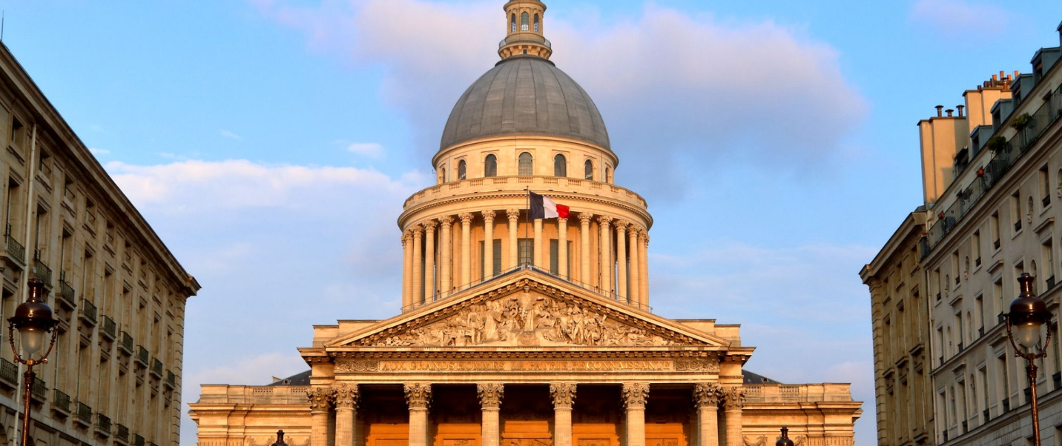

1. **Eiffel Tower (La Tour Eiffel):**

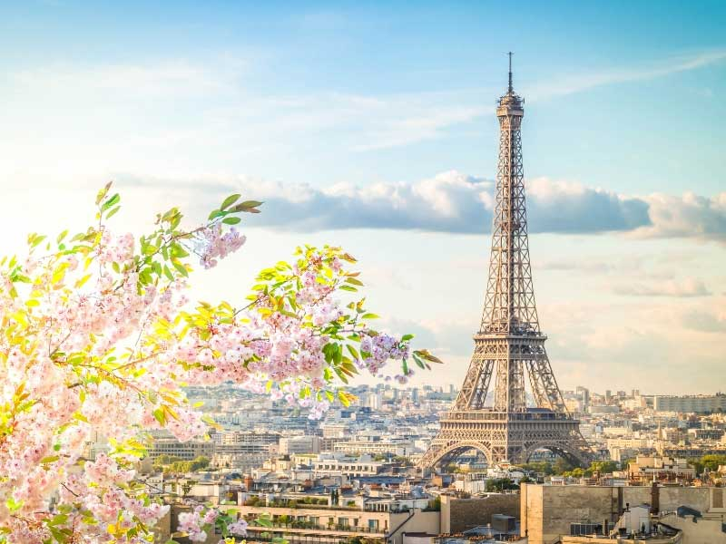The Eiffel Tower is the most famous landmark in Paris. It was built in 1889 for a world fair and is made of iron. It is very tall and looks like a triangle with four legs. You can go up by stairs or by lift to see the amazing view of the city. At night, it lights up and sparkles every hour. Many people take photos with it because it’s so iconic. It’s a symbol of Paris and of France.

1. **Palace of the Popes (Palais des Papes):**

The Palace of the Popes is in the city of Avignon in southern France. It was once the home of several Popes during the 1300s. The building looks like a big stone castle with towers and thick walls. Inside, there are many rooms, halls, and beautiful old paintings. It shows how powerful and rich the Popes were at that time. Visitors can walk through the palace and learn about its history. It is one of the largest Gothic buildings in Europe.

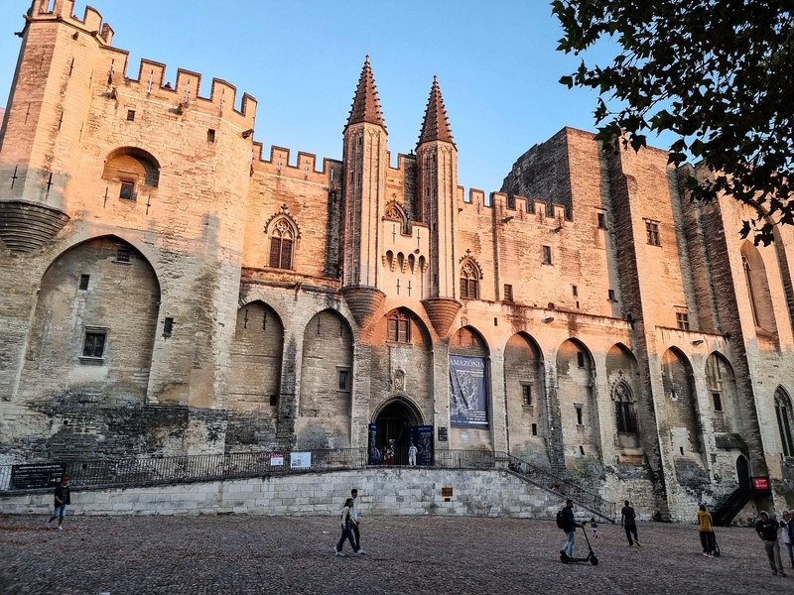

1. **Luxembourg Palace:**

The Luxembourg Palace is a big and beautiful building in Paris. It was built in the 1600s for a queen to live in. Today, it is used by the French Senate. The palace is inside a pretty park called the Luxembourg Gardens. People love to visit this place to relax, walk, or enjoy the fountains and flowers. The building looks fancy with old-style windows and strong stone walls. Kids can sail toy boats in the pond, and families have picnics on the grass. It’s a calm and happy spot in the busy city.

The gardens also have statues, trees, and even a small playground. Artists and musicians sometimes perform there. It’s a fun and peaceful place for everyone to enjoy.

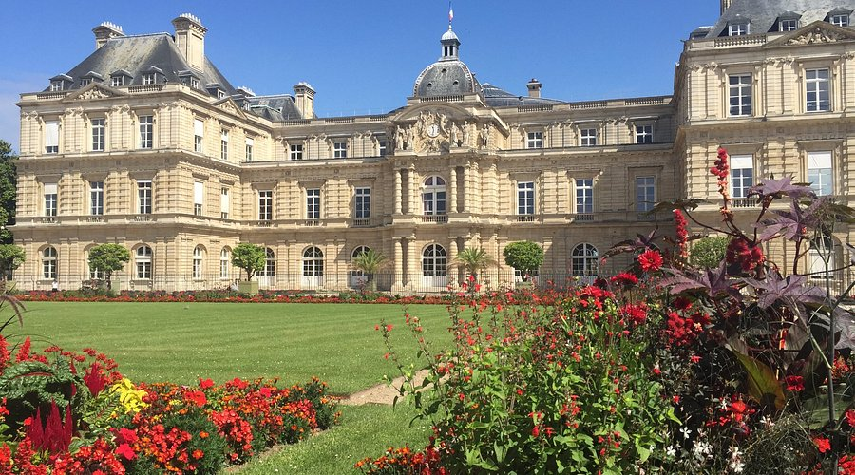**Conclusion:**

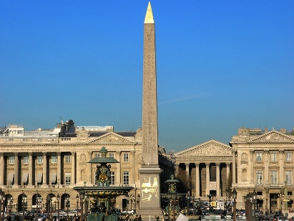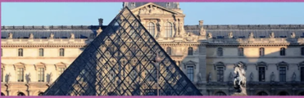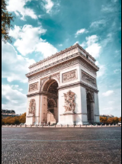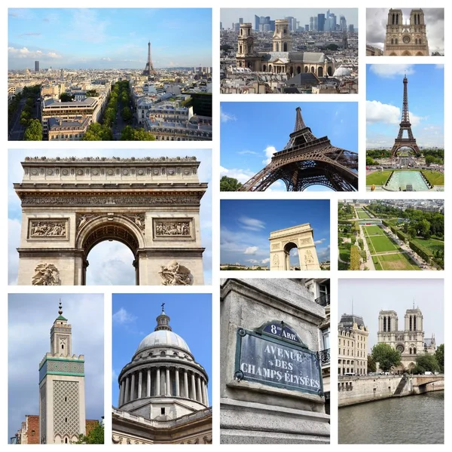French monuments show the rich history and culture of the country. They are beautiful and important landmarks that many people visit. Each monument tells a story about France’s past. These monuments make France special and unique.